Article type:

Title
(Sample)Positive Effects of the Asian Journal of Beauty and Cosmetology on Beauty and Cosmetology-related Studies and Industries in Korea

Author’s name and Affiliation
(Sample)Gil-Dong Hong¹, Hong-Lyun Jang¹, Shim Chug ², Gap Dol Kim³, Daehan Lee¹*
¹Department of Cosmetology, Gildong University, Seoul, Korea
²Department of Dermatology, Janghong University School of Medicine, Changwon-si, Gyeongsangnam-do, Korea
³Skin Research Center, Hankook, Ltd., Beijing, China

*Corresponding author: Daehan Lee, Department of Cosmetology, Gildong University, 123 Jungang-ro, Gwangjin-gu, Seoul 05029, Korea
Tel.: +82 2 1234 5678, Fax: +82 2 1234 7890, Email:dhlee@gildong.ac.kr

Running title: Effects of the Asian Journal of Beauty and Cosmetology on Beauty and Cosmetology-related Studies and Industries.

Abstracts
Purpose :
Methods :
Results :
Conclusion :

KeyWords: Effect, Korean journal, Aesthetics, Cosmetology, Industry

Page separation
以下是研究论文(Research article)的列子
评论论文（Review article）的内容需按照 Introduction，本文（英语标题可自由选用），Conclusions的顺序来撰写

Ⅰ. Introduction

1)

Ⅱ. Methods

1)

Ⅲ. Results and Discussion

1)

Ⅳ. Conclusion

1)

Acknowledgements

Page separation
References
Example
学术杂志 （作者姓名. 题目. 杂志名称，卷: 页-页，年.）
Lee BM, Kwon SB, An SK, Ahn KJ, An IS. The guideline of cosmetics labels and advertisements and regulations for verification in Korea. Korean Journal of Aesthetics and Cosmetology, 11: 11-15, 2013.
Ichikawa A, Takagi H, Suda K, Yao T. New methodological approach for the rapid and sensitive detection of melanocytes and melanocytic tumors: the DOPA-GA method. Dermatology, 219: 195-201, 2009.

单行本(作者. 单行本. 出版社名, 出版地名, 引用页数(pp000-000), 出版年度.)
Ha BJ. Cosmetic Science. Soomoonsa Publishing, Gyeonggi-do, pp99-104, 2010.
Hall A, Morris JDH, Price B, Lloyd A, Hancock JF, Gardener S, Houslay MD, Wakelam MJ, Marshall CJ. Effects of the Korean Journal of Aesthetics and Cosmetology on aesthetics-related studies and industries in the world. In: Aesthetics and Cosmetology. Spandidos DA (ed.), Plenum Publ. Corp., New York, pp99-104, 1989.

Page separation
Table sample
Table 1. Inhibitory effects of black ginseng extracts
Group | Amount (pg/mL)
 | IL-6 | IL-8 | MCP-1
Control | 19.4±1.4 | 76.5±5.3 | 31.2±1.4
Extracts of BG radix | 607.3±17.9* | 1656.5±29.4* | 194.8±6.4*
Extracts of BG leaf | 534.5±19.9* | 1394.0±26.3* | 121.7±4.7*
Data are means±S.D. of 3 experiments.
*p<.05, **p<.01, and ***p<.001 significantly different as compared to DpE group.

Figure sample

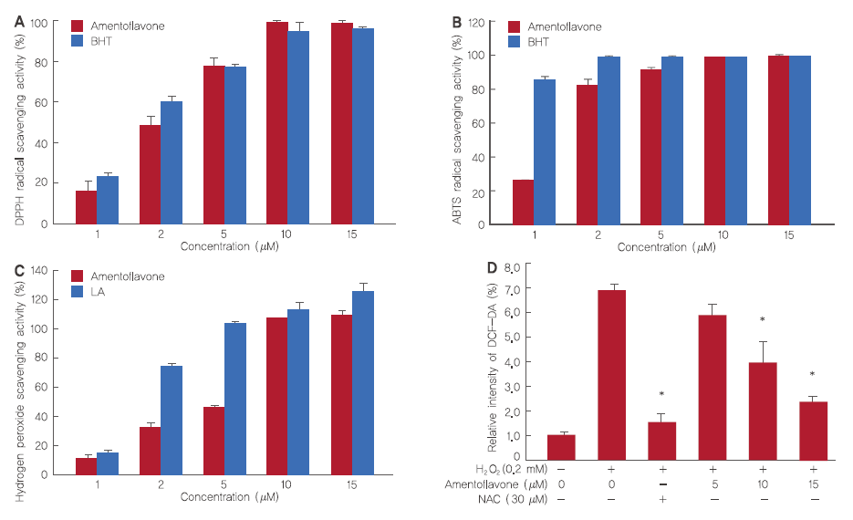
Figure 1. Antioxidant effects of amentoflavone.
(A) Electron donating ability from amentoflavone. (B) ABTS⁺ radical cation scavenging activity of amentoflavone. (C) Hydrogen peroxide scavenging ability of amentoflavone. (D) The intracellular ROS levels in H₂O₂-treated HDFs. The Student’s t-test was performed to determine statistical significance (*p<.05).

Page separation
中文摘要
Example
亚洲美容化妆品杂志对韩国国内美容和化妆品行业及相关学科的积极影响

洪吉东¹, 张红莲¹, 沈清², 金甲³, 李大韩¹*
¹化妆品学科, 吉东大学校, 首尔, 韩国
²皮肤科, 长虹医科大学校, 庆尚南道 昌原市, 韩国
³皮肤研究中心, （株）韩国, 北京, 中国

*联络作者 : 李大韩,
吉东大学校 化妆品学科, 首尔 广津区 中江路 123
Tel.: +82 2 1234 5678, Fax: +82 2 1234 7890, Email: dhlee@gildong.ac.kr

目的:
方法:
结果:
结论:

关键词: 5个

感谢语

中文参考文献
黄霏莉, 闫志安.中医美容学的人体审美.中国医药学报, 15: 8-11, 2000.

