Article type:

Title
(Sample)Positive Effects of the Asian Journal of Beauty and Cosmetology on Beauty and Cosmetology-related Studies and Industries in Korea

Author’s name and Affiliation
(Sample)Gil-Dong Hong¹, Hong-Lyun Jang¹, Shim Chug², Gap Dol Kim³, Daehan Lee^{1*}
¹Department of Cosmetology, Gildong University, Seoul, Korea
²Department of Dermatology, Janghong University School of Medicine, Changwon-si, Gyeongsangnam-do, Korea
³Skin Research Center, Hankook Ltd., Beijing, China

*Corresponding author: Daehan Lee, Department of Cosmetology, Gildong University, 123 Jungang-ro, Gwangjin-gu, Seoul 05029, Korea
Tel.: +82 2 1234 5678, Fax: +82 2 1234 7890, Email:dhlee@gildong.ac.kr

Running title: Effects of the Asian Journal of Beauty and Cosmetology on Beauty and Cosmetology-related Studies and Industries.

Abstracts
Purpose:
Methods:
Results:
Conclusion:

Keywords: Effect, Korean journal, Aesthetics, Cosmetology, Industry

Page separation
아래는 연구논문(Research article)의 본문 구성 예시입니다.
총설논문(Review article)의 본문은 Introduction, 본론(영문 표제를 자유롭게 사용), Conclusion의 순서대로 기술합니다.

Ⅰ. Introduction

1)

Ⅱ. Methods

1)

Ⅲ. Results and Discussion

1)

Ⅳ. Conclusion

1)

Acknowledgements

Page separation
References
Example
학술지일 경우 (저자. 논문제목. 학술지명, 권: 페이지-페이지, 출판년도.)
Lee BM, Kwon SB, An SK, Ahn KJ, An IS. The guideline of cosmetics labels and advertisements and regulations for verification in Korea. Korean Journal of Aesthetics and Cosmetology, 11: 11-15, 2013.
Ichikawa A, Takagi H, Suda K, Yao T. New methodological approach for the rapid and sensitive detection of melanocytes and melanocytic tumors: the DOPA-GA method. Dermatology, 219: 195-201, 2009.

단행본일 경우(저자. 단행본명. 출판사명, 출판지명, 인용페이지(pp000-000), 출판년도.)
Ha BJ. Cosmetic Science. Soomoonsa Publishing, Gyeonggi-do, pp99-104, 2010.
Hall A, Morris JDH, Price B, Lloyd A, Hancock JF, Gardener S, Houslay MD, Wakelam MJ, Marshall CJ. Effects of the Korean Journal of Aesthetics and Cosmetology on aesthetics-related studies and industries in the world. In: Aesthetics and Cosmetology. Spandidos DA (ed.), Plenum Publ. Corp., New York, pp99-104, 1989.

Page separation
Table sample
Tables

Table 1. Inhibitory effects of black ginseng extracts
Group | Amount (pg/mL)
 | IL-6 | IL-8 | MCP-1
Control | 19.4±1.4 | 76.5±5.3 | 31.2±1.4
Extracts of BG radix | 607.3±17.9* | 1656.5±29.4* | 194.8±6.4*
Extracts of BG leaf | 534.5±19.9* | 1394.0±26.3* | 121.7±4.7*
Data are means±S.D. of 3 experiments.
*p<.05, **p<.01, and ***p<.001 significantly different as compared to DpE group.

Figure sample
Figures
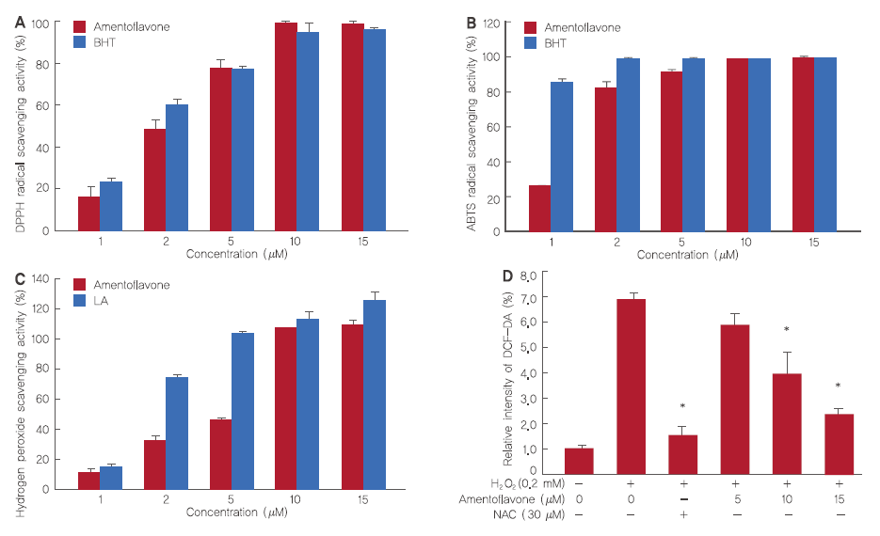
Figure 1. Antioxidant effects of amentoflavone.
(A) Electron donating ability from amentoflavone. (B) ABTS⁺ radical cation scavenging activity of amentoflavone. (C) Hydrogen peroxide scavenging ability of amentoflavone. (D) The intracellular ROS levels in H₂O₂-treated HDFs. The Student’s t-test was performed to determine statistical significance (*p<.05).

Page separation
국문초록
Example
아시아뷰티화장품학술지가 국내 미용 및 화장품 관련 학문 및 산업에 미치는 긍정적인 영향

홍길동¹, 장홍련¹, 심청², 김갑돌³, 이대한¹*
¹화장품학과, 길동대학교, 서울, 한국
²피부과, 장홍의과대학교, 경상남도 창원시, 한국
³피부연구센터, ㈜한국, 베이징, 중국

*교신저자 : 이대한
길동대학교 화장품학과, 서울시 광진구 중강로 123길
Tel.: +82 2 1234 5678, Fax: +82 2 1234 7890, Email: dhlee@gildong.ac.kr

목적:
방법:
결과:
결론:

핵심어: 5개

감사의 글

참고문헌
이보미, 권승빈, 안성관, 안인숙. 국내 화장품 표시·광고 관리 가이드라인 및 실증에 관한 규정. 대한피부미용학회지, 11: 11-15, 2013

